|  |  |  |  |  |  |  |  |  |  |
| --- | --- | --- | --- | --- | --- | --- | --- | --- | --- |
| **SCHOOL OF COMPUTER SCIENCE AND ARTIFICIAL INTELLIGENCE** | | | | | **DEPARTMENT OF COMPUTER SCIENCE ENGINEERING** | | | | |
| **Program Name:** B. Tech | | | | **Assignment Type: Lab** | | | **Academic Year:**2025-2026 | | |
| **Course Coordinator Name** | | | | Venkataramana Veeramsetty | | | | | |
| **Instructor(s) Name** | | | | |  | | --- | | Dr. V. Venkataramana (Co-ordinator) | | Dr. T. Sampath Kumar | | Dr. Pramoda Patro | | Dr. Brij Kishor Tiwari | | Dr.J.Ravichander | | Dr. Mohammand Ali Shaik | | Dr. Anirodh Kumar | | Mr. S.Naresh Kumar | | Dr. RAJESH VELPULA | | Mr. Kundhan Kumar | | Ms. Ch.Rajitha | | Mr. M Prakash | | Mr. B.Raju | | Intern 1 (Dharma teja) | | Intern 2 (Sai Prasad) | | Intern 3 (Sowmya) | | NS_2 ( Mounika) | | | | | | |
| **Course Code** | | | 24CS002PC215 | **Course Title** | | AI Assisted Coding | | | |
| **Year/Sem** | | | II/I | **Regulation** | | R24 | | | |
| **Date and Day**  **of Assignment** | | | Week6 - Monday | **Time(s)** | |  | | | |
| **Duration** | | | 2 Hours | **Applicable to**  **Batches** | |  | | | |
| **AssignmentNumber:12.5**(Present assignment number)/**24**(Total number of assignments) | | | | | | | | | |
|  | | | | | | | | | |
|  | **Q.No.** | **Question** | | | | | | ***Expected Time***  ***to complete*** |  |
|  | 1 | **Lab 12: Algorithms with AI Assistance – Sorting, Searching, and Optimizing Algorithms**  **Lab Objectives:**   * Apply AI-assisted programming to implement and optimize sorting and searching algorithms. * Compare different algorithms in terms of efficiency and use cases. * Understand how AI tools can suggest optimized code and complexity improvements.   **Task 1: Sorting Student Records for Placement Drive**  **Scenario:** SR University is preparing for a campus placement drive. The Training and Placement Cell needs student records sorted by **CGPA** in descending order to easily shortlist candidates.   * Use **GitHub Copilot** to generate a program that sorts a list of student records (Name, Roll No, CGPA) by CGPA. * Implement both **Quick Sort** and **Merge Sort** using AI assistance. * Compare the runtime performance of both algorithms on large datasets. * Write a function that outputs the **top 10 students** with the highest CGPA.   **Task 2: Optimized Search in Online Library System**  **Scenario:** SR University’s digital library has thousands of research papers. Students frequently search for a paper by **title or author name**. The current linear search is too slow.   * Use **GitHub Copilot** to implement **Binary Search** and **Hash-based Search** for faster lookups. * Load a dataset of book titles and authors (CSV or JSON file). * Allow the user to input a keyword and return all matching entries. * Compare the efficiency of **linear search vs binary search vs hashing** using test cases.   **Task 3: Route Optimization for AUV Swarm**  **Scenario:** A research team at SR University is simulating **Autonomous Underwater Vehicle (AUV) swarms**. Each AUV must visit multiple underwater sensors, and the goal is to minimize travel distance (like the **Traveling Salesman Problem**).   * With **GitHub Copilot**, implement an algorithm to optimize the route:   1. Start with a **Greedy approach**.   2. Improve with **Genetic Algorithm (GA)** or **Simulated Annealing (SA)**. * Use a dataset of sensor coordinates (x, y). * Visualize the optimized route using a plotting library (e.g., Matplotlib). * Compare the optimized solution with a random path in terms of distance travel.   **Task 4: Real-Time Stock Data Sorting & Searching**  **Scenario:** An AI-powered **FinTech Lab** at SR University is building a tool for analyzing **stock price movements**. The requirement is to quickly **sort stocks by daily gain/loss** and search for specific stock symbols efficiently.   * Use **GitHub Copilot** to fetch or simulate stock price data (Stock Symbol, Opening Price, Closing Price). * Implement sorting algorithms to rank stocks by **percentage change**. * Implement a **search function** that retrieves stock data instantly when a stock symbol is entered. * Optimize sorting with **Heap Sort** and searching with **Hash Maps**. * Compare performance with standard library functions (sorted(), dict lookups) and analyze trade-offs.   Top of Form | | | | | | Week6 - Friday |  |

**Task 1: Sorting Student Records for Placement Drive**

**Scenario:**  
SR University is preparing for a campus placement drive. The Training and Placement Cell needs student records sorted by **CGPA** in descending order to easily shortlist candidates.

* Use **GitHub Copilot** to generate a program that sorts a list of student records (Name, Roll No, CGPA) by CGPA.
* Implement both **Quick Sort** and **Merge Sort** using AI assistance.
* Compare the runtime performance of both algorithms on large datasets.
* Write a function that outputs the **top 10 students** with the highest CGPA.

Prompt:

Write a python program to sort student records (Name, Roll No, CGPA) by CGPA in descending order using Quick Sort and Merge Sort, compare their runtimes, and print the top 10 students.

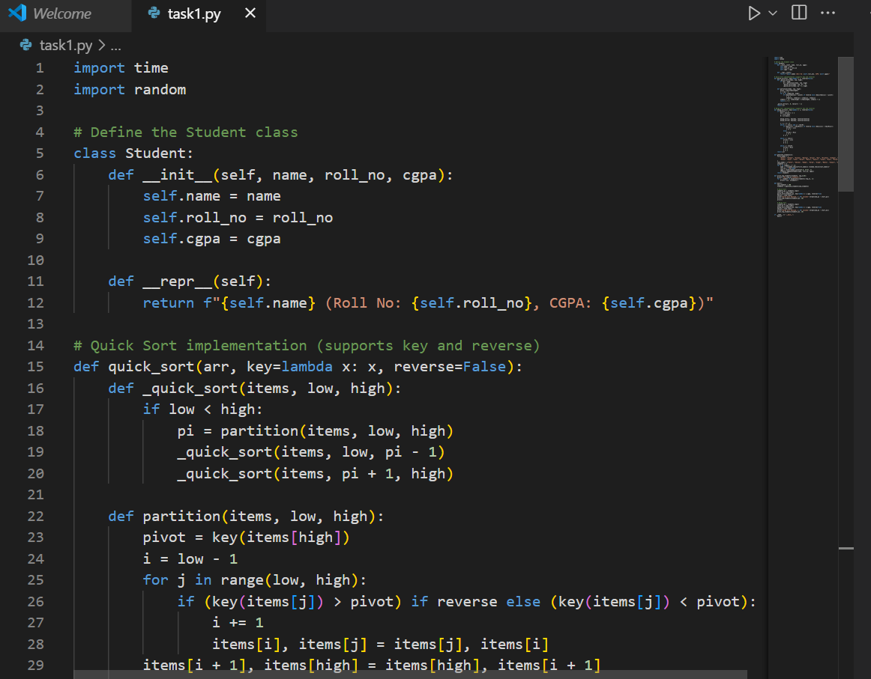

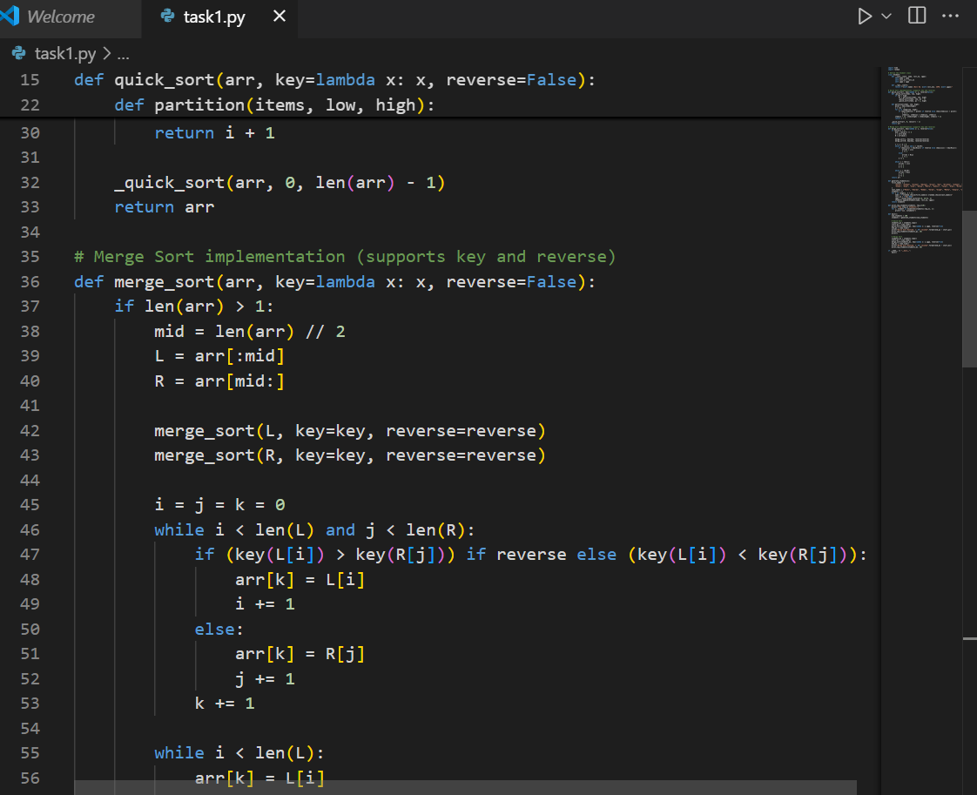

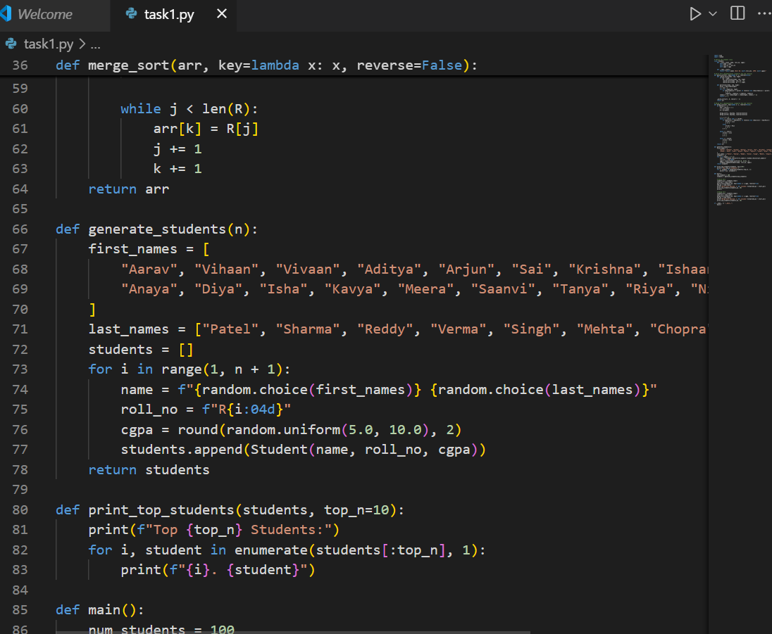

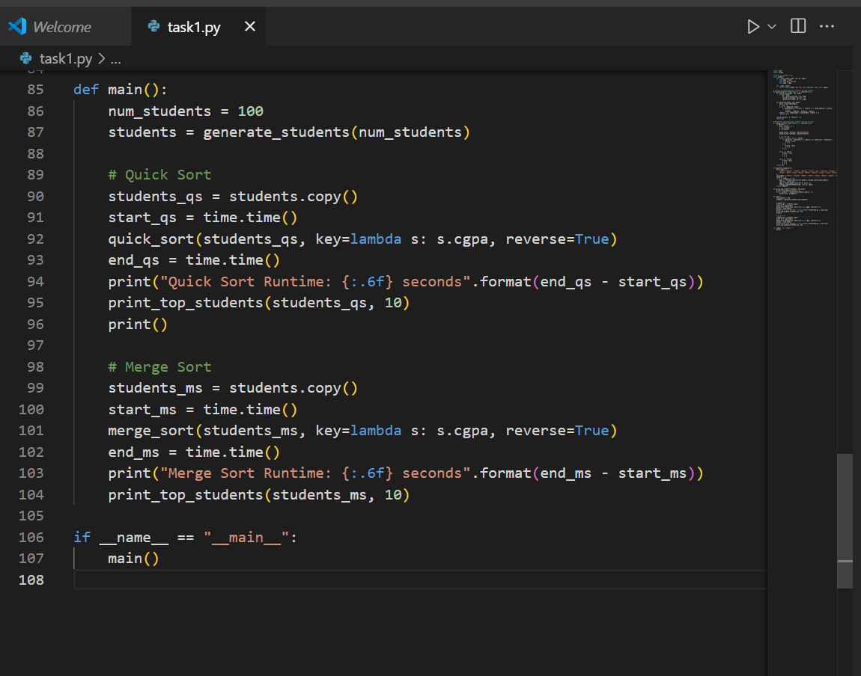

Output:

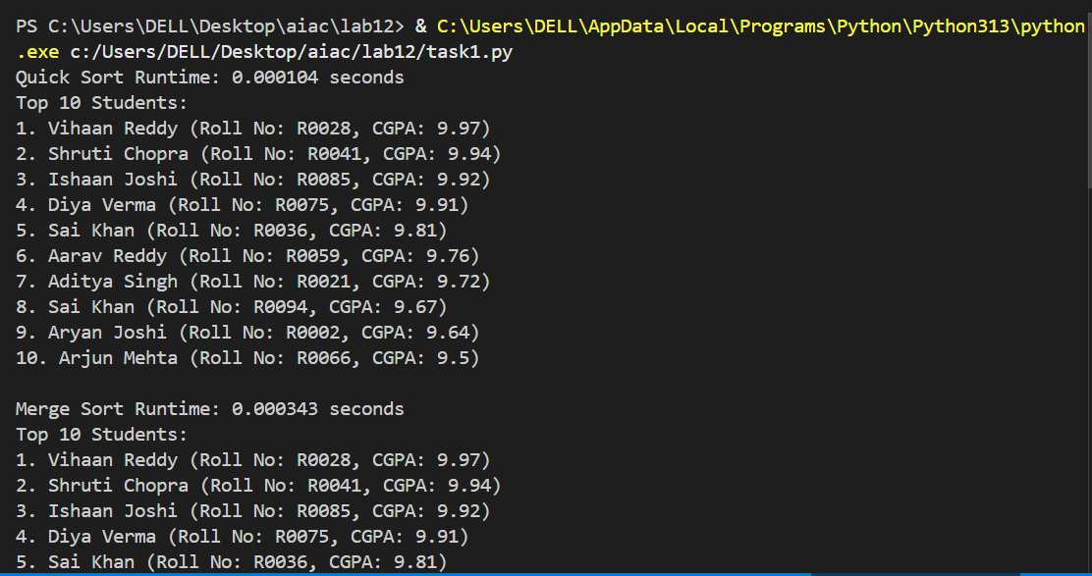

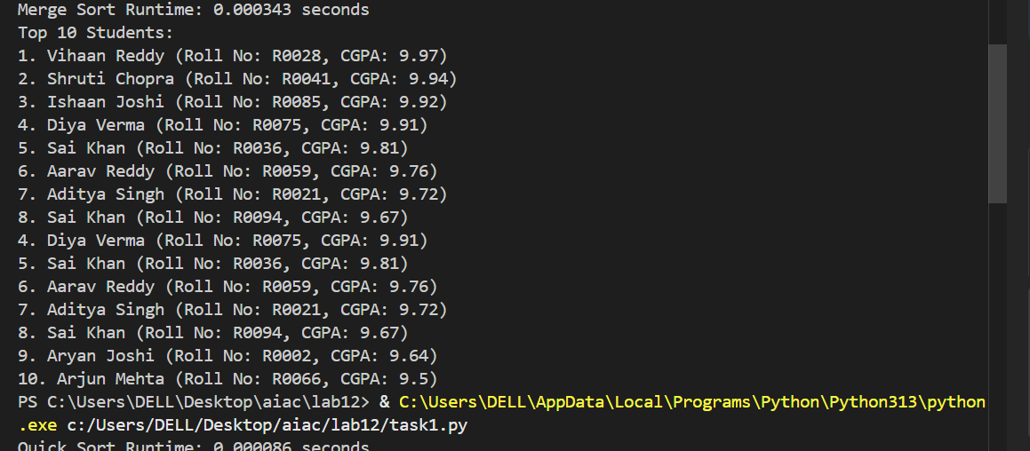

**Task 2: Optimized Search in Online Library System**

**Scenario:**  
SR University’s digital library has thousands of research papers. Students frequently search for a paper by **title or author name**. The current linear search is too slow.

* Use **GitHub Copilot** to implement **Binary Search** and **Hash-based Search** for faster lookups.
* Load a dataset of book titles and authors (CSV or JSON file).
* Allow the user to input a keyword and return all matching entries.
* Compare the efficiency of **linear search vs binary search vs hashing** using test cases.

Prompt:

Write a Python program to load a CSV of book titles and authors, and implement linear search, binary search, and hash-based search to find books by keyword, compare their runtimes, and return matching results.

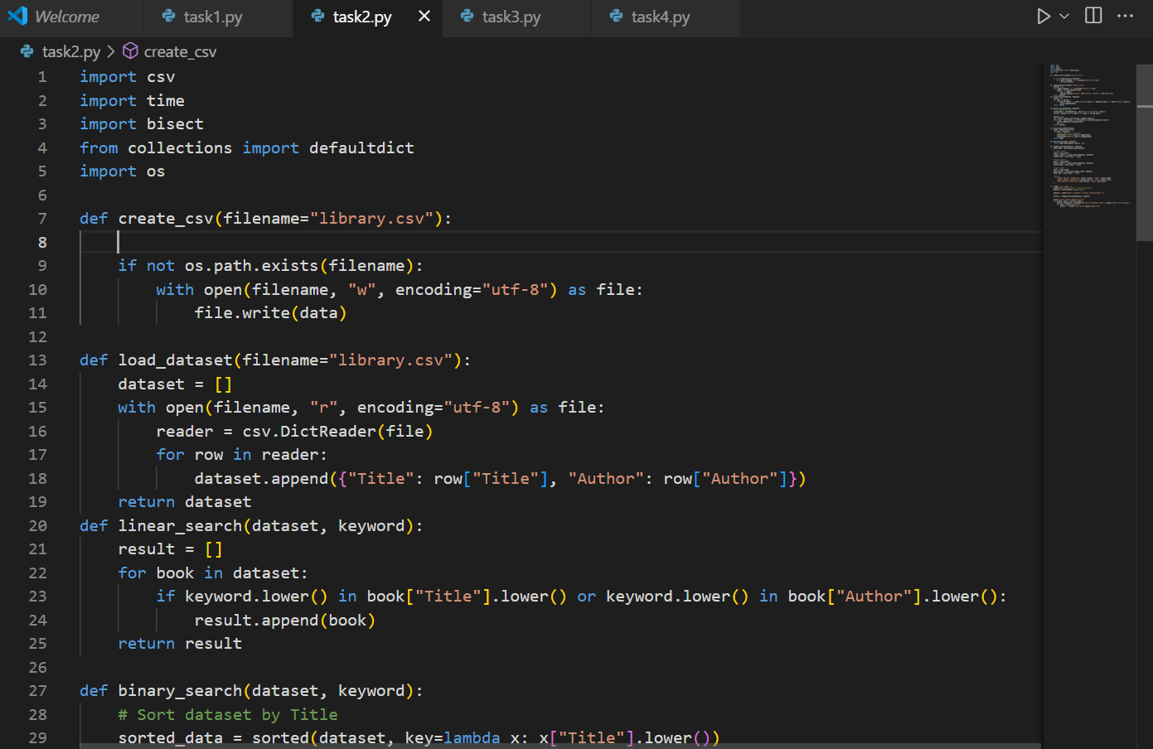

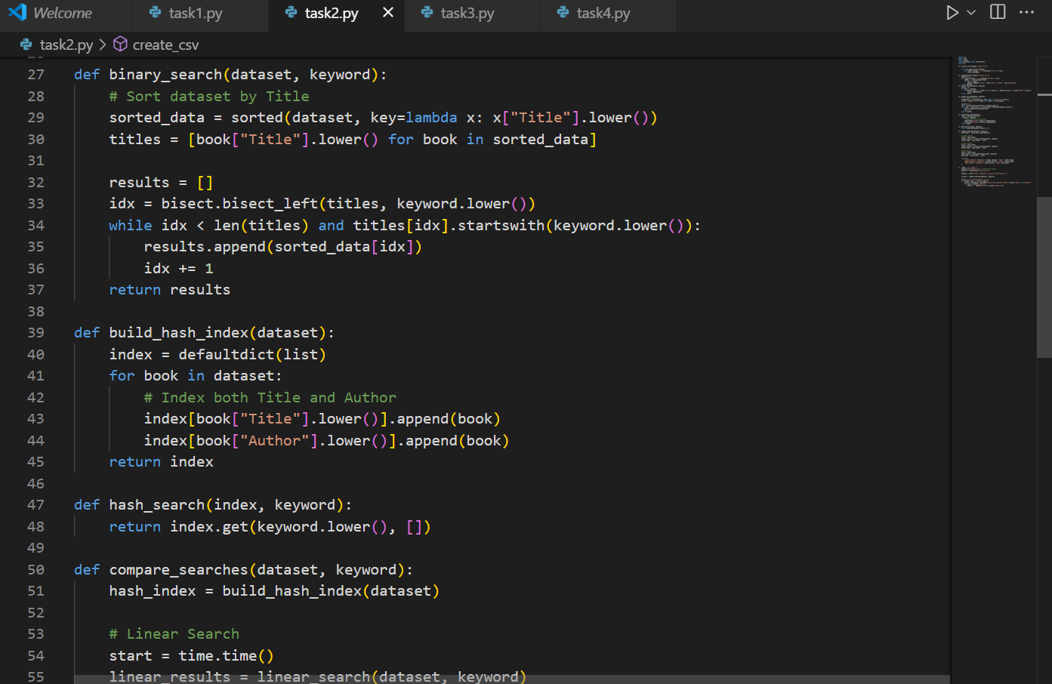

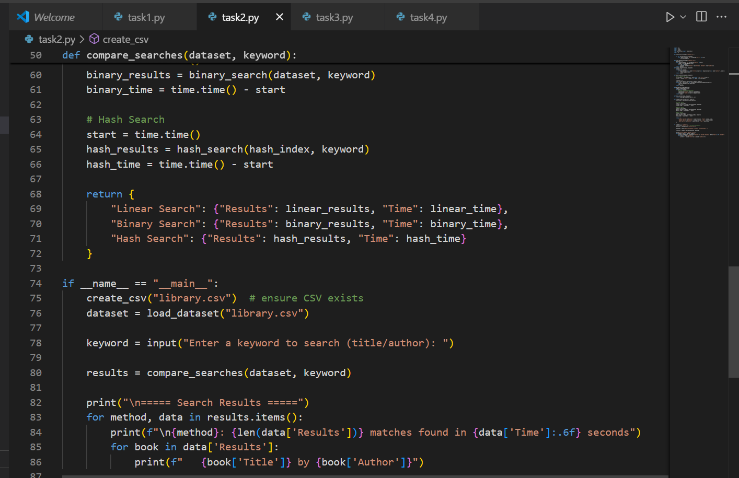

Output:

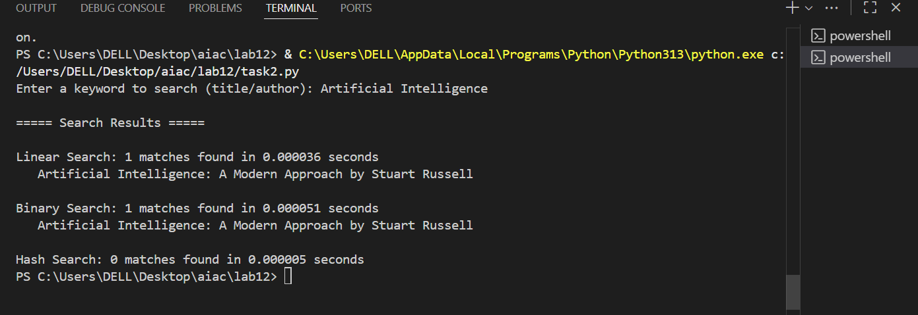

**Task 3: Route Optimization for AUV Swarm**

**Scenario:**  
A research team at SR University is simulating **Autonomous Underwater Vehicle (AUV) swarms**. Each AUV must visit multiple underwater sensors, and the goal is to minimize travel distance (like the **Traveling Salesman Problem**).

* With **GitHub Copilot**, implement an algorithm to optimize the route:
  1. Start with a **Greedy approach**.
  2. Improve with **Genetic Algorithm (GA)** or **Simulated Annealing (SA)**.
* Use a dataset of sensor coordinates (x, y).
* Visualize the optimized route using a plotting library (e.g., Matplotlib).
* Compare the optimized solution with a random path in terms of distance travel.

Promot:

Implement an algorithm to optimize the route. Start with a Greedy approach. Improve with Genetic Algorithm (GA) or Simulated Annealing (SA).Use a dataset of sensor coordinates (x, y) and Visualize the optimized route using a plotting library (e.g.,Matplotlib).and also Compare the optimized solution with a random path in terms of distance travel

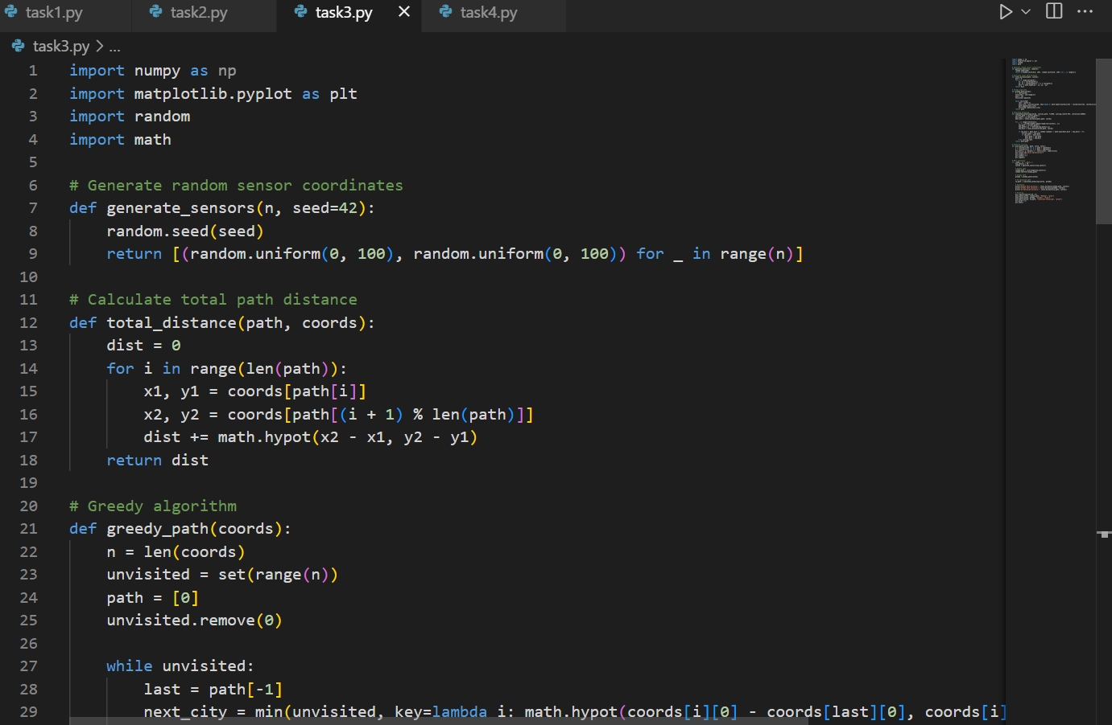

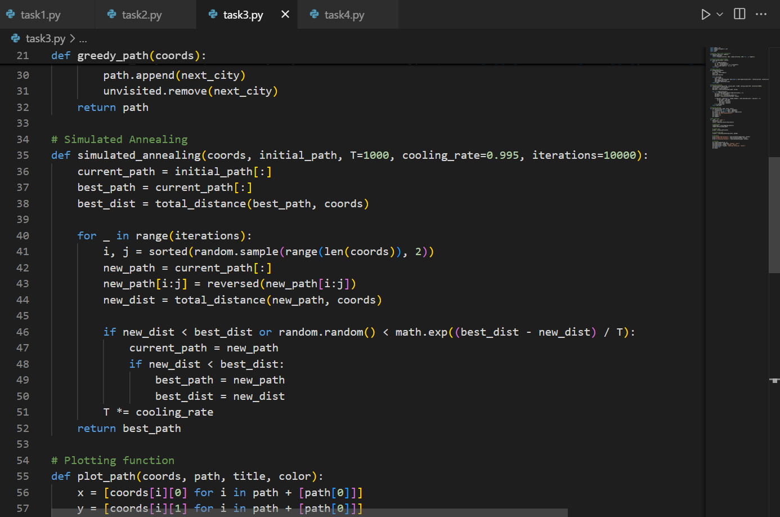

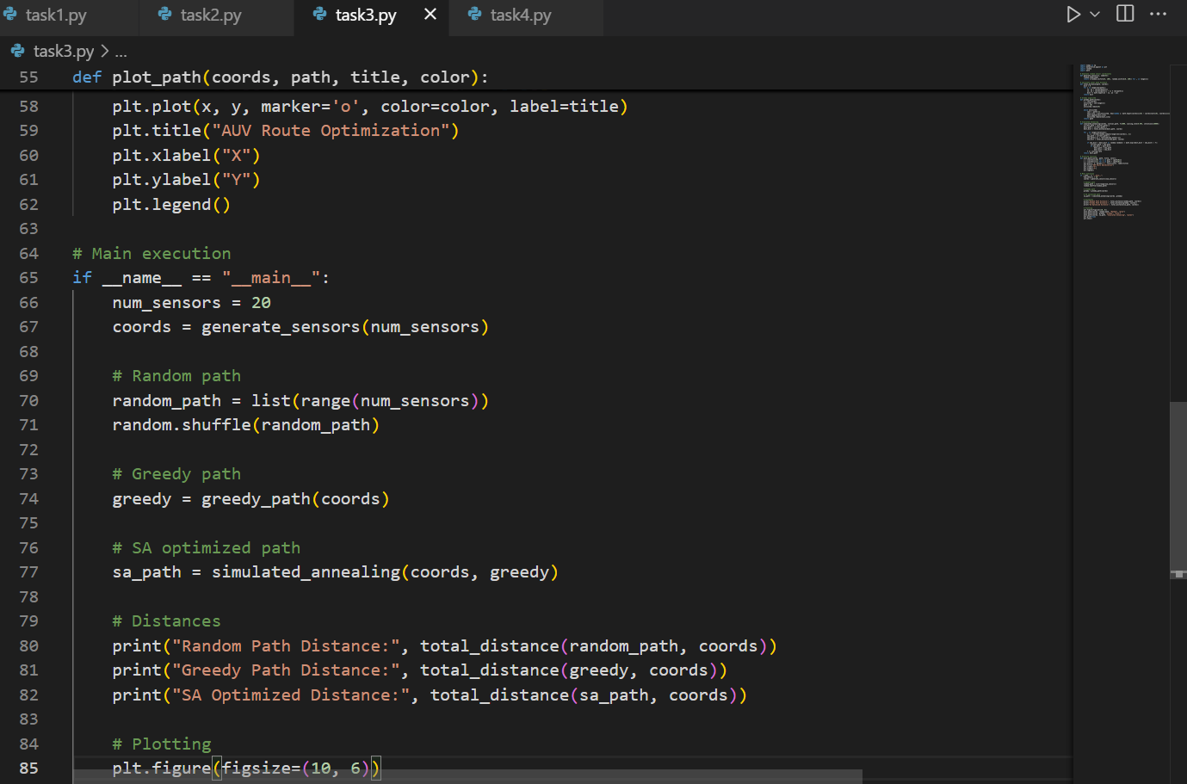

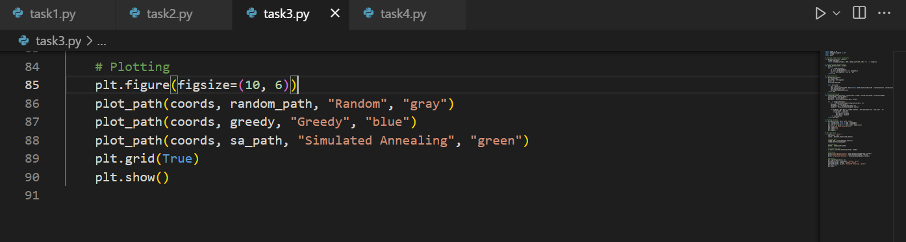

Output:

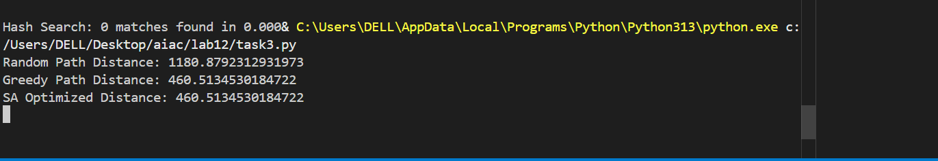

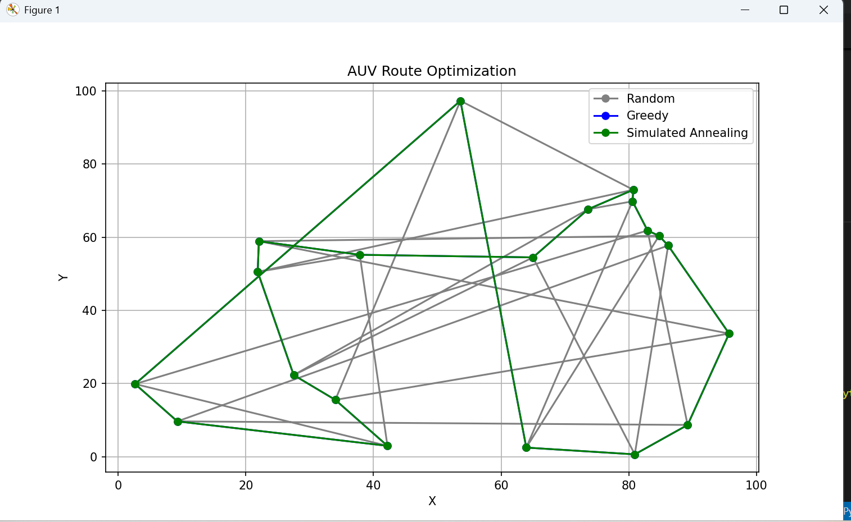

**Task 4: Real-Time Stock Data Sorting & Searching**

**Scenario:**  
An AI-powered **FinTech Lab** at SR University is building a tool for analyzing **stock price movements**. The requirement is to quickly **sort stocks by daily gain/loss** and search for specific stock symbols efficiently.

* Use **GitHub Copilot** to fetch or simulate stock price data (Stock Symbol, Opening Price, Closing Price).
* Implement sorting algorithms to rank stocks by **percentage change**.
* Implement a **search function** that retrieves stock data instantly when a stock symbol is entered.
* Optimize sorting with **Heap Sort** and searching with **Hash Maps**.
* Compare performance with standard library functions (sorted(), dict lookups) and analyze trade-offs.

Prompt:

Fetch or simulate stock price data (Stock Symbol, Opening Price, Closing Price and Implement sorting algorithms to rank stocks by percentage change. Then Implement a search function that retrieves stock data instantly when a stock symbol is entered And also Optimize sorting with Heap Sort and searching with Hash Maps .Compare performance with standard library functions (sorted(),dict lookups) and analyze trade-offs.

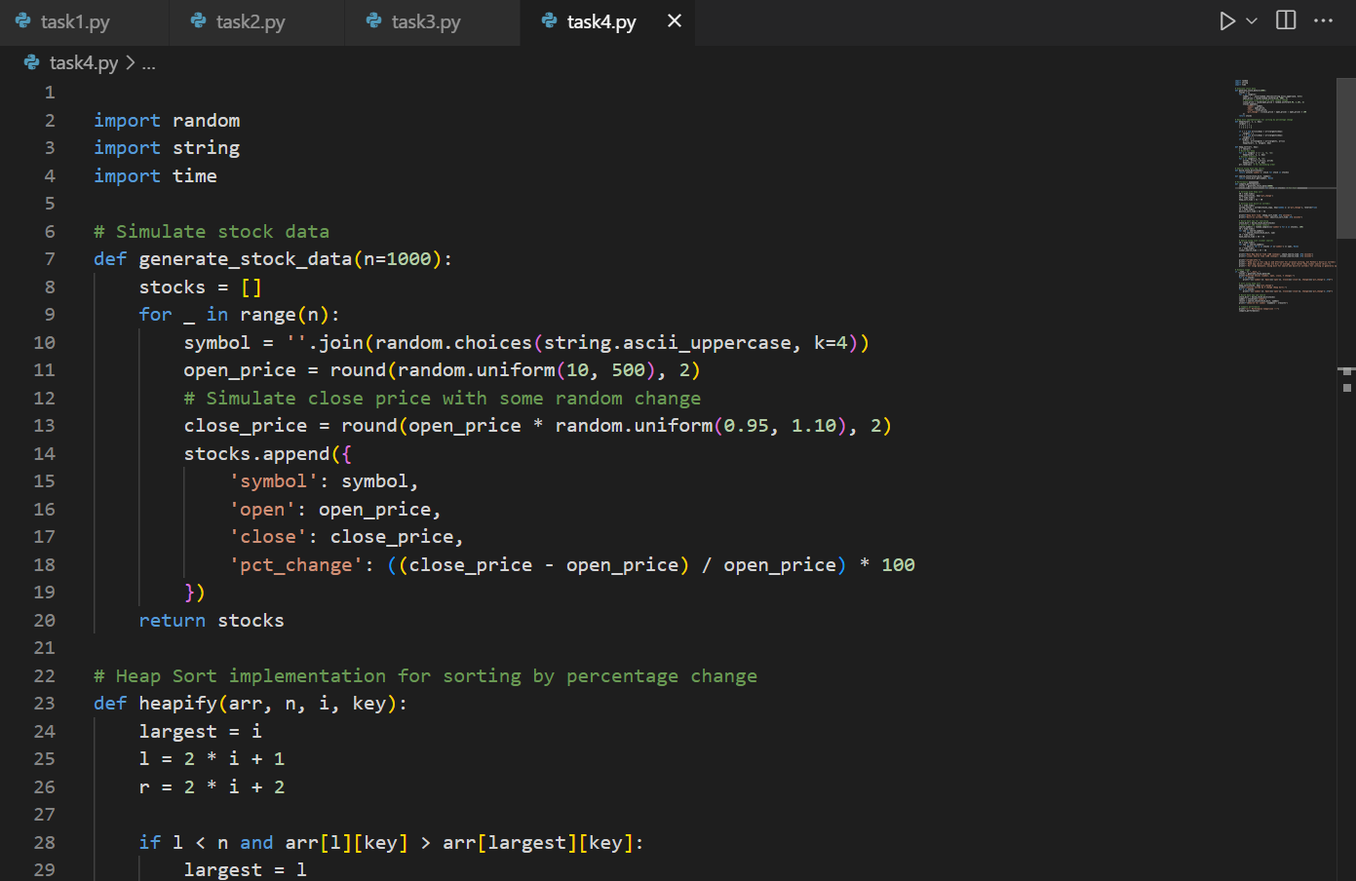

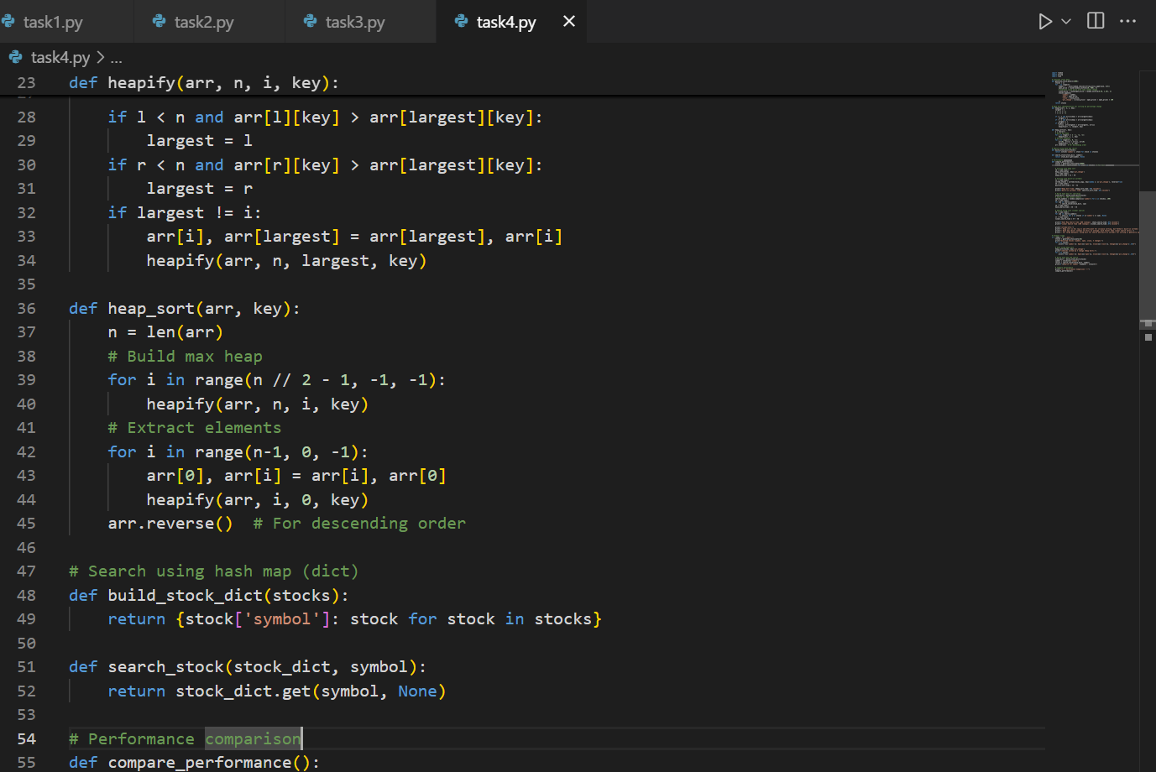

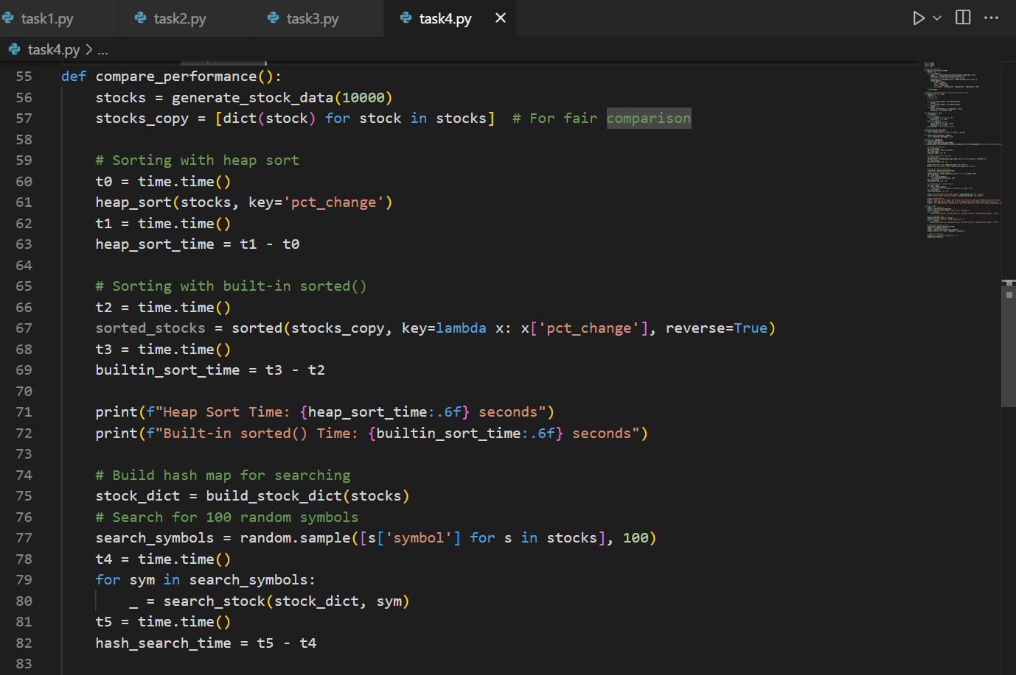

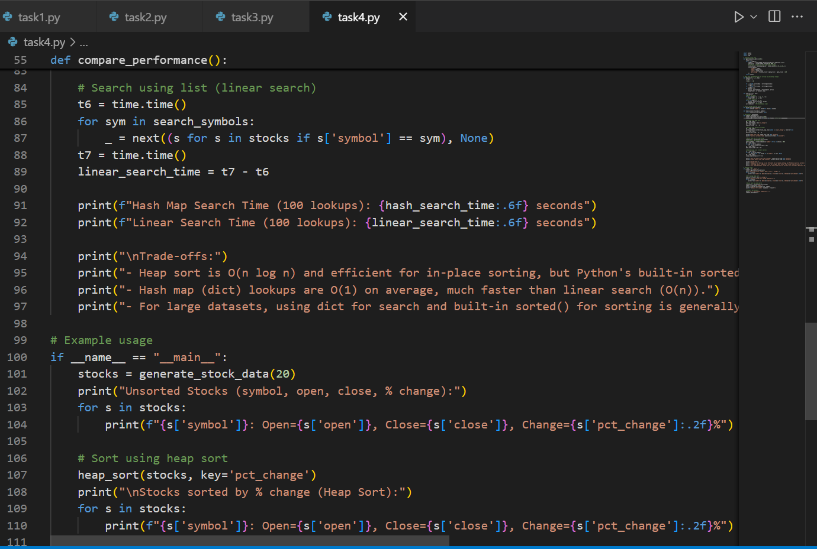

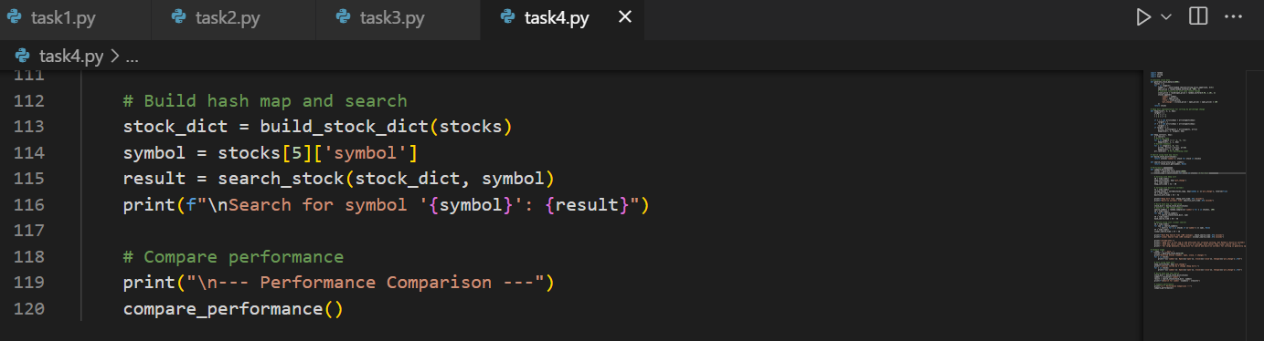

Output:

